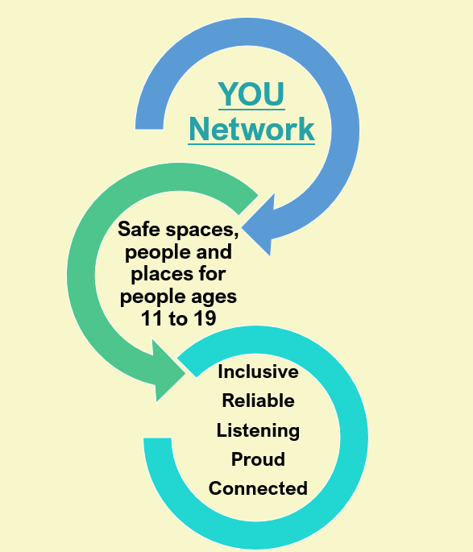
If you have read the YOU Network information pack and are interested in becoming part of the network please complete the form and we will contact you with links to a choice of 2 online meetings in September 2024 to go through the benefit, vision and aims of the network, to give you a chance to ask questions of the steering group and find out anything you need to.
After those meetings you will be invited to join the network which will launch in November 2024.
For any further enquiries community@salisburycitycouncil.gov.uk

Organisation, group or project name
Lead contact (your name)
Contact email
Contact Number
Where did you hear about the YOU Network?
Does your activity, group or project already exist? | YES | NO
Tell us about your activity, project or club.
Do you already meet our eligibility criteria (see info pack) or would you want support with some of that?
Are you able to attend meetings online? | YES | NO

