You Network Registration Form
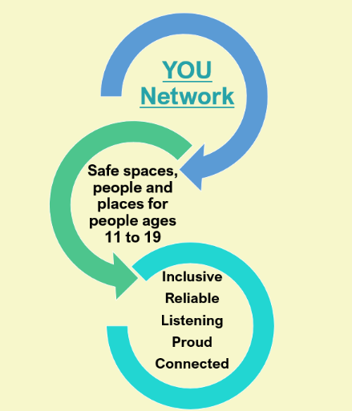
Please return this registration form along with
- Safeguarding Policy
- Lone working policy
(if not included in safeguarding Policy)
- Public Liability Certificate
To: communities@salisburycitycouncil.gov.uk

Support Available:
If you have any questions about the information you need for this form or would like some advice on any element of the form the YOU network can provide you with a buddy to look at the form with you. We understand that people setting up new group sand initiatives may not all everything in place and the network is here to help!

Which of the following applies to your provision?
(Highlight as appropriate)
- B) C)
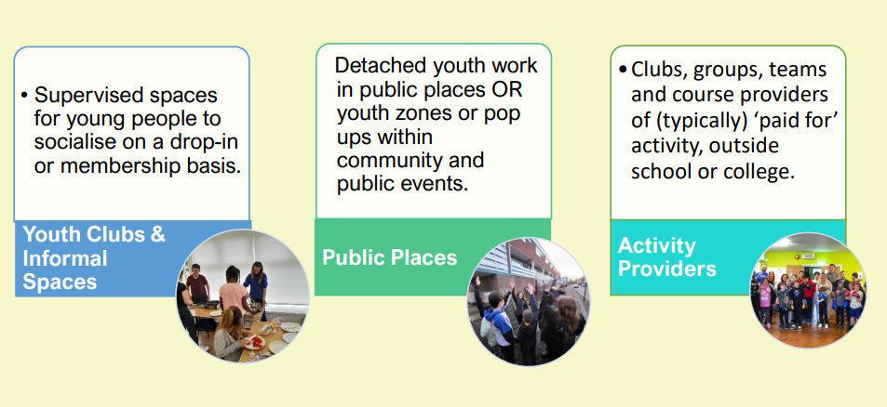
YOU Network Registration Form
Organisations Name:
Lead Contact Name:
Phone Number:
Email address:
Central or generic contact details for your group or organisation.
Website link or link to any online information about your organisation, activity or group.
Do you have a safeguarding policy?  (Please send with this registration form). | YES NO
Do you have a policy on lone working with young people or a section within the safeguarding policy that covers procedures.  (Please send with this registration form). | YES NO
What Level of Public Liability Insurance do you have?
If you are operating under the polices or insurance of another organisation, please provide a named contact for that organisation so that we can verify the arrangements. | Name:  Phone:  Email:
YOU Network Values
How do you connect with each of the values of the YOU Network in the way you support or work with young people?
Inclusive:
Come as YOU are.
Everyone is welcome regardless of gender, sexuality, gender identity, religion, or culture. The only criteria for entry into spaces or services can be age, or geographical location. Access and individual needs are considered, and adjustments made wherever possible to create a space of safety. Difference is celebrated in both small and big ways.
Reliable:
Here for YOU
Members of the network work hard to provide a consistent or reliable safe space by either having regular or clearly communicated dates and opening times, operating in the same places or having a clear identity that young people know they can trust.
Listening:
Hearing what YOU have to say.
We place listening to young people at the heart of our work, one-to one, in groups, formally and informally, we actively seek their feedback and input into how a space or service operates. We give young people a voice and enable them to shape outcomes.
Proud:
Celebrating YOU.
Through the YOU network, and our youth provision forum partners, we actively share positive news stories about, by and for young people in and around Salisbury, supporting Young People to share who they are.
Connected:
Will you as an organisation commit to the following
- List our activity on the ALL Together Wiltshire Website Young People Area, and keep it up to date.
- Share information about the work of other YOU network members with your community.
- Share information about your work with the wider network.
- Attend network meetings twice a year online
Do you agree to an annual visit from a member of the Youth Provision Forum Steering group. | YES NO
Service/Activities provided
If you are one providing more than 1 safe space, you will need to register each space.
1 . Activity Club or Service description
Age range
Day/time
Location
Sign up/registration detail
Lead contact for this activity
If this is a paid for activity what are your provisions for access such as bursary placements, fee subsidies etc
How do you include the voices and ideas of young people in the way you run your setting
What is your maximum number of young people who can attend at once?
What is your minimum number of DBS checked adults who need to be in attendance?
(This could be described as a minimum ratio)
Who is your safeguarding lead?
(Please include contact details)
What training do you, your staff and/or your volunteers have?
(Requirements may be different in each setting)
What is your first aid provision?
2 . Activity Club or Service description
Age range
Day/time
Location
Sign up/registration detail
Lead Contact for this activity
If this is a paid for activity what are your provisions for access such as bursary placements, fee subsidies etc
How do you include the voices and ideas of young people in the way you run your setting
What is your maximum number of young people who can attend at once?
What is your minimum number of DBS checked adults who need to be in attendance?
(This could be described as a minimum ratio)
Who is your safeguarding lead?
(Please include contact details)
What training do you, your staff and/or your volunteers have.
(Requirements may be different in each setting)
What is your first aid provision?
2 . Activity Club or Service description
Age range
Day/time
Location
Sign up/registration detail
Lead Contact for this activity
If this is a paid for activity what are your provisions for access such as bursary placements, fee subsidies etc
How do you include the voices and ideas of young people in the way you run your setting
What is your maximum number of young people who can attend at once?
Whist is your minimum number of DBS checked adults who need to be in attendance?
(This could be described as a minimum ratio)
Who is your safeguarding lead?
(Please include contact details)
What training do you, your staff and/or your volunteers have.
(Requirements may be different in each setting)
What is your first aid provision?

